Advanced Mechatronics Engineering

MCTR903

Assignment 1

Submitted by:

1. Abd El-rahman Saad 43-16084 T-22
2. Ahmed Zaghloul 43-15854 T-27
3. Bishoy Atef 43-16090 T-30
4. John Gameel 43-15785 T-30
5. Mona Elboughdady 43-16697 T-21

Submitted to:

1. Prof. Ayman A. El-Badawy
2. M.Sc Catherine Elias
3. M.Sc Lobna Tarek
4. M.Sc Dalia Mamdouh
5. M.Sc. Ahmed Fahmy

**Table of content**

1.Mealy and Moore machines

2. MATLAB and Simulink implementation

3. Using switches or signal builders to change the input

4. Plots showing triggering inputs and how this would change the

states and the outputs.

5. Uploading the code on Arduino UNO.

6. Arduino hardware and output.

7. Comparison between the Mealy and Moore machines.

8. Comments on performance.

**Problem1 Solution**

Part 1:

A) Mealy Machine

States:

* : First floor
* : Second floor
* : Third floor.

Inputs:

* : Go to the 1st floor
* : Go to the 2nd floor
* : Go to the 3rd floor

Outputs:

* : Go up one floor
* : Go up two floors
* : Go down one floor
* : Go down one floor
* : Do nothing

State Diagram:

/

/

“2nd floor”

“1st floor”

/

/

/

/

/

/

“3rd floor”

/

State transition table:

|  |  |  |  |
| --- | --- | --- | --- |
| Input  State |  |  |  |
|  |  |  |  |
|  |  |  |  |
|  |  |  |  |

B) Moore Machine

States:

* : First floor
* : Second floor
* : Third floor
* : 1st to 2nd
* : 2nd to 1st
* : 1st to 3rd
* : 3rd to 1st
* : 2nd to 3rd
* : 3rd to 2nd.

Inputs:

* : Go to the 1st floor
* : Go to the 2nd floor
* : Go to the 3rd floor

Outputs:

* : Go up one floor
* : Go up two floors
* : Go down one floor
* : Go down one floor
* : Do nothing

State Diagram:

1st to 2nd

“3rd floor”

“1st floor”

3rd to 1st

2nd to 1st

3rd to 2nd

1st to 2nd

2nd to 3rd

“2nd floor”

State transition table:

* Some cases are undefined.
* This is solved using self transition.

|  |  |  |  |  |
| --- | --- | --- | --- | --- |
| Input State/output | |  |  |  |
| /s |  |  |  |  |
| /s |  |  |  |  |
| /s |  |  |  |  |
| / |  |  |  |  |
| / |  |  |  |  |
| / |  |  |  |  |
| / |  |  |  |  |
| / |  |  |  |  |
| / |  |  |  |  |

Simplified solution

States:

* : First floor
* : Second floor
* : Third floor
* : Going up one floor
* : Going down one floor
* : Going up two floors
* : Going down two floors

Inputs:

* : Go to the 1st floor
* : Go to the 2nd floor
* : Go to the 3rd floor

Outputs:

* : Go up one floor
* : Go up two floors
* : Go down one floor
* : Go down one floor
* : Do nothing

State Diagram:

“up one floor”

“1st floor”

“2nd floor”

“down one floor”

“2nd floor”

“down two floor”

“up two floor”

“3rd floor”

“2nd floor”

“1st floor”

State transition table:

|  |  |  |  |  |
| --- | --- | --- | --- | --- |
| Input  State/output | |  |  |  |
| /s |  |  |  |  |
| /s |  |  |  |  |
| /s |  |  |  |  |
| / |  |  |  |  |
| / |  |  |  |  |
| / |  |  |  |  |
| / |  |  |  |  |

Part2: Simulink and MATLAB code

Mealy machine MATLAB function



Moore machine MATLAB function





Modified Moore machine MATLAB function





Simulations can be stepped manually using Simulink controls or using pacing option in Simulink to show the state transition. Discrete solvers were not used as the output was still too fast as the simulation was still running far too fast.

Simulink model for Mealy and Moore machines with switches and a scope

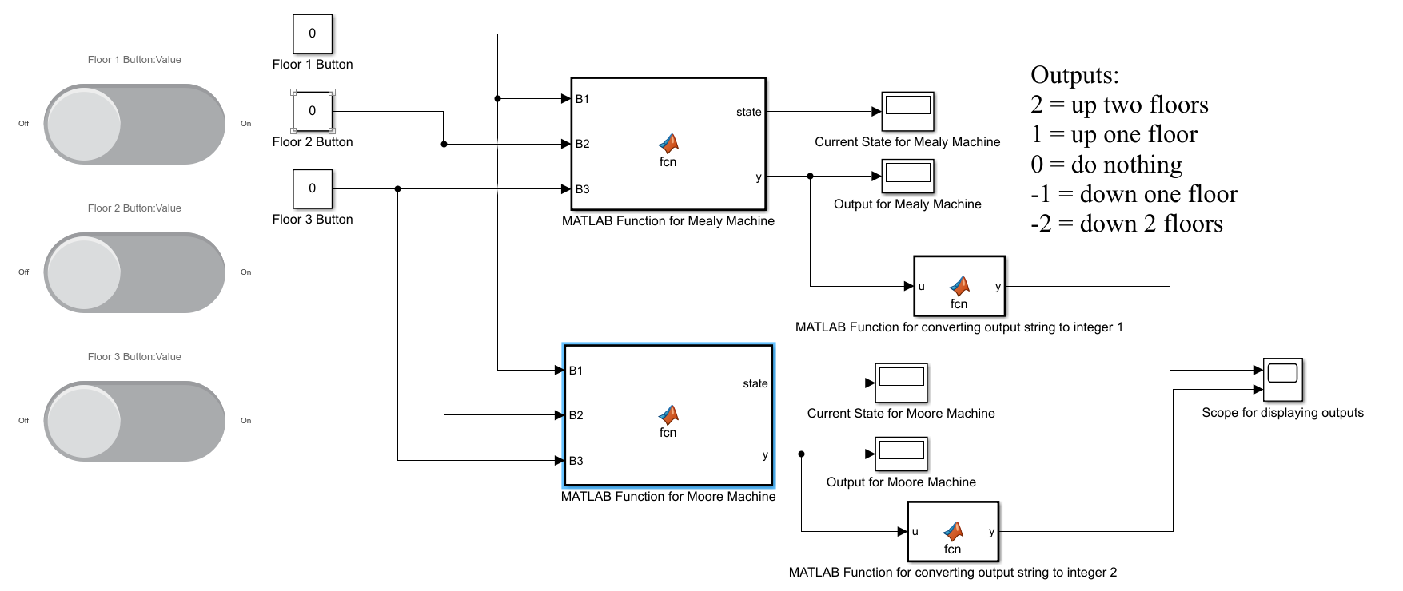

Simulink model of the Mealy machine for Arduino

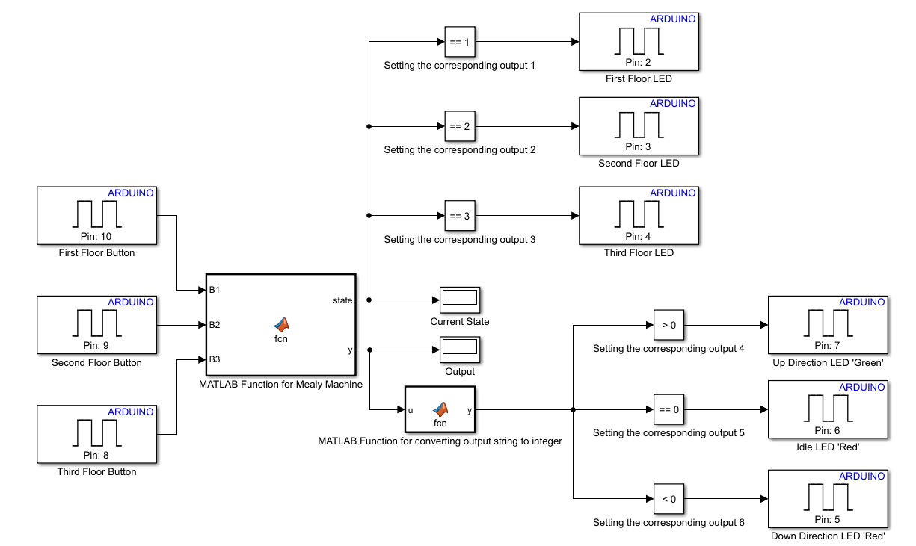

Simulink model of the Moore machine for Arduino

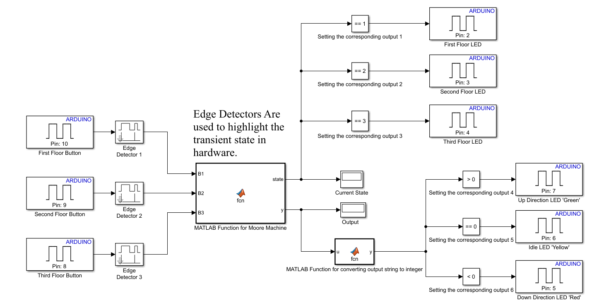

Part3: Using switches or signal builders to change the input

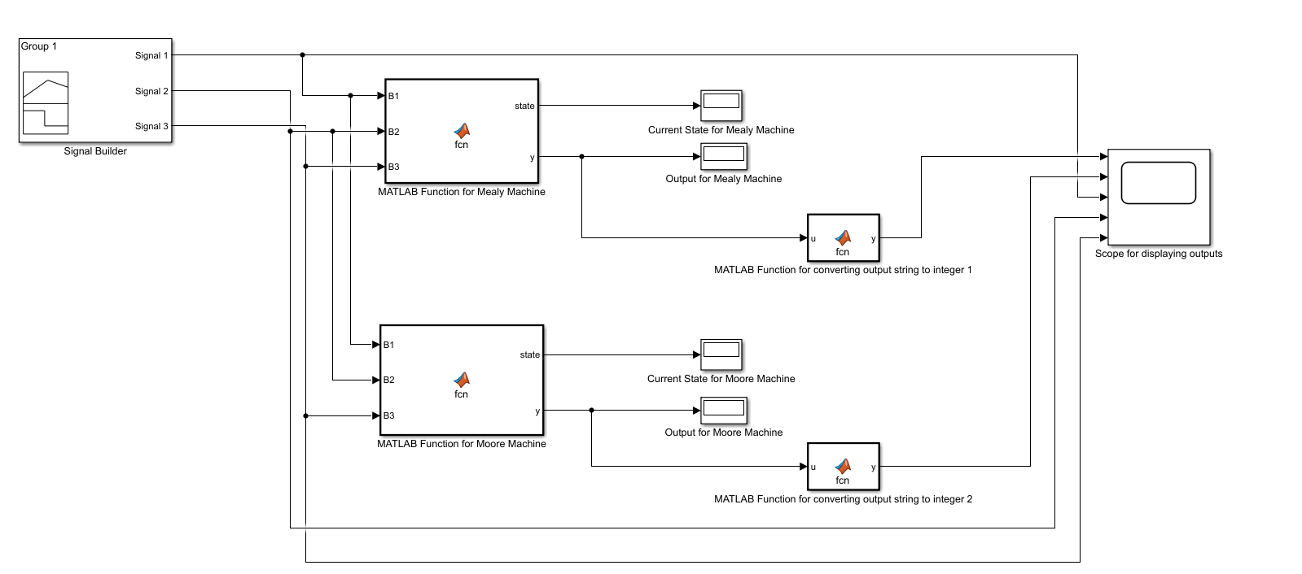

Signals used in the signal builder

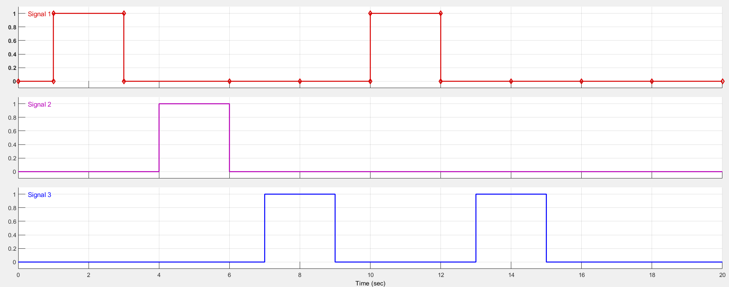

Part 4: Plots showing triggering inputs and how this would change the

states and the outputs.

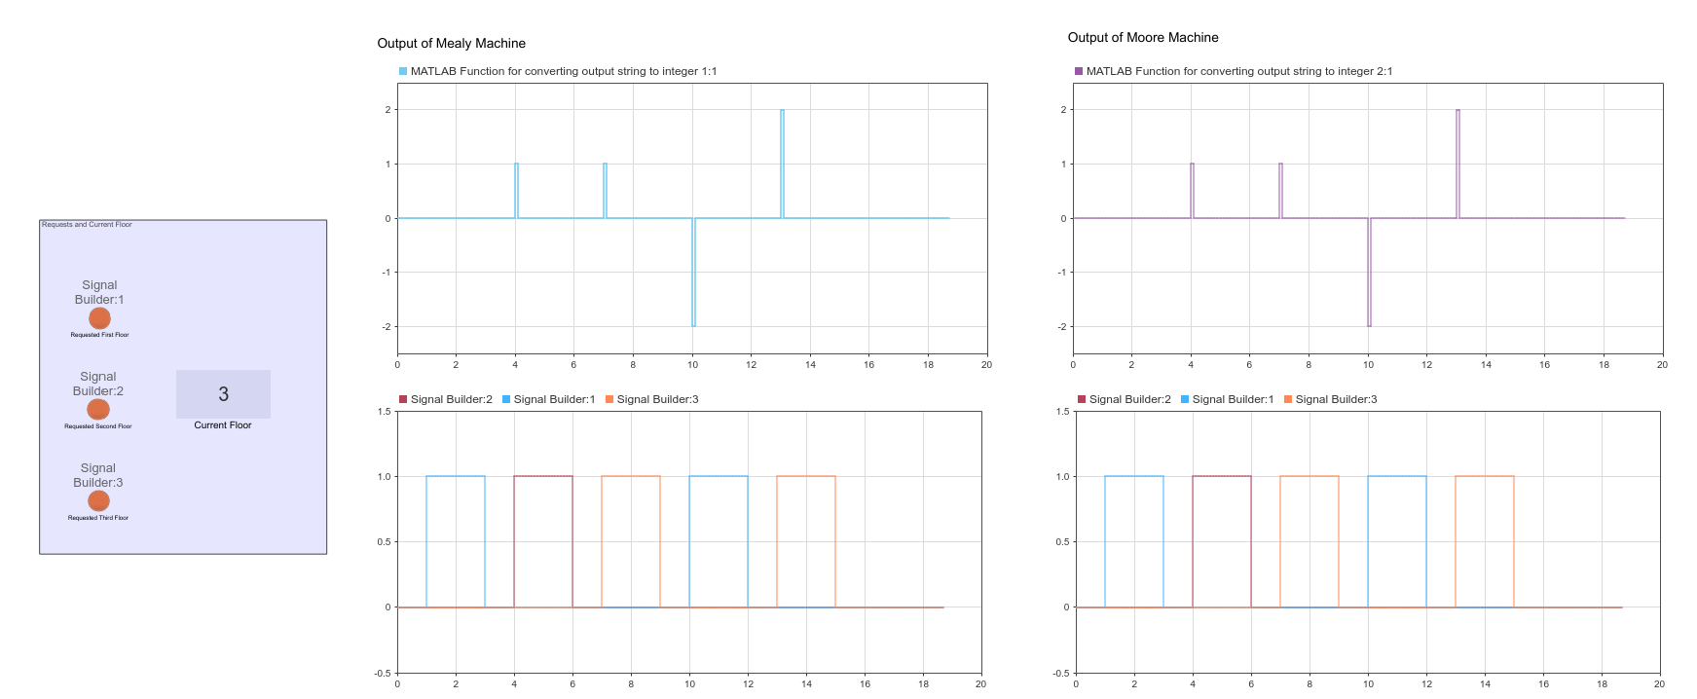

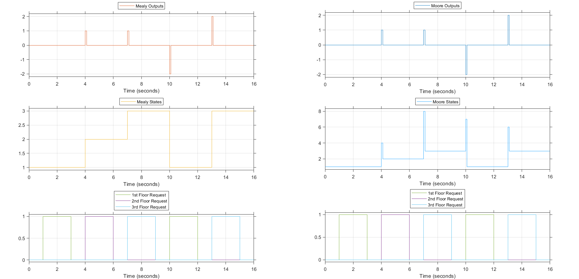

As can be seen in the previous graph the Mealy machine reaches the required floor state as soon as it gets an input while the Moore machine goes through a transient state and if the input to the machine is still the same it moves from this transient state to the required state. Going to the transient states is emphasized in the hardware implementation by using edge detection as can be seen in the hardware model for the Moore machine.

Part 5: Uploading the code on Arduino UNO

The code is uploaded using the Simulink support package for Arduino hardware.

Part 6. Arduino hardware and output.

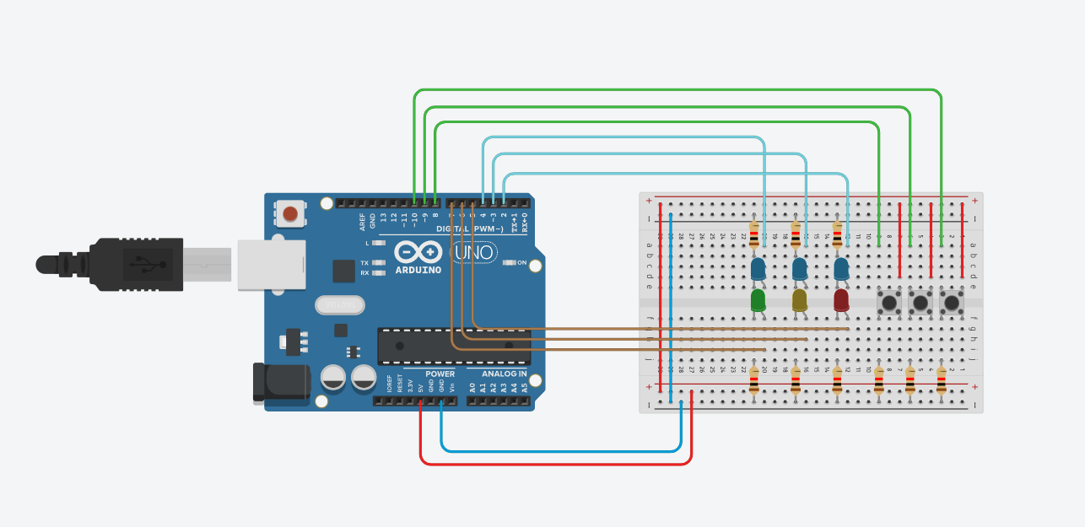

The result of running the code on the hardware can be seen in the attached video.

Part 7. Comparison between the Mealy and Moore machines.

The Mealy and Moore machine both achieve the task successfully. The Mealy machine has less states than both Moore machines. Mealy machine consists of 3 states while Moore and modified Moore machines consist of 9 and 7 states respectively. The Mealy machine outputs the actuator action as soon as it gets a request and reaches the required floor after one transition. The Moore machine transitions first to a transient state which outputs the actuator action after which if the input to the machine remains the same it transitions to the required floor. This means that Mealy machine requires one transition and Moore requires two transitions to reach requested floor in this case.

8. Comments on performance.

The Mealy machine has less states which requires less coding and overall less checks in the code while both Moore machines contain more states which requires more checks from the CPU in a simple system, such as this, this is not apparent. Another aspect is transitions Mealy machines require less transitions to reach the requested floor in this case while the difference is not apparent from a time perspective in MATLAB’s simulation, stepping the simulation makes it apparent that this is the case. Both machines have their pitfalls as there is no mention of time in the FSM and sending commands to the actuators is not guarded by sensor signals that make sure that the elevator truly reached its destination.